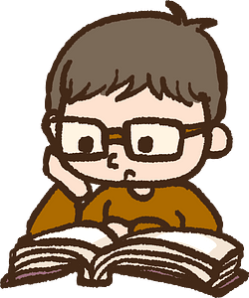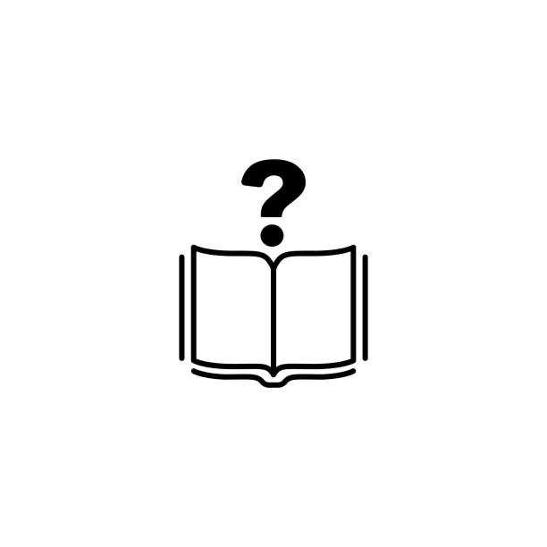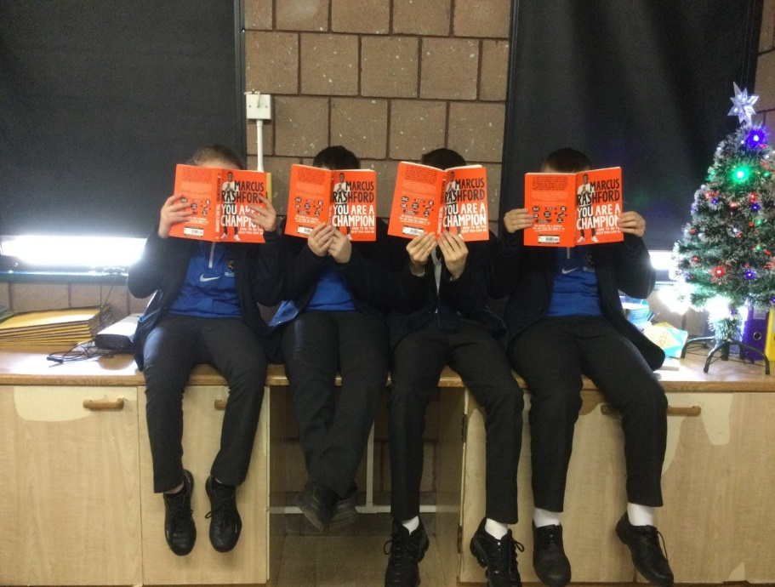

*Literacy at Laurelhill – Advice sheet*

***How is Literacy assessed at Laurelhill?***  
  
Literacy is assessed across the curriculum in every subject, not just in English class. Communication is one of the three cross curricular skills as part of the Northern Ireland curriculum, which encompasses the skills of Talking and Listening, Reading, and Writing.  
  
Good literacy skills are important to ensure your child can access the curriculum and achieve their fullest academic potential.

Pupil progress in literacy is monitored via PTE testing throughout their time at Laurelhill.

***What is my role as a parent?***  
  
Supporting your child’s literacy development at home is a must and is a huge part of their developmental needs. You can help by:  
  
- Offering a print rich environment in the home, with access to books, magazines, comics, newspapers that are relevant and interesting to your child.

- Playing word games together e.g. Wordle, talk about the meanings of words and point out new or interesting words to broaden their vocabulary.

- For younger children, participate in joint reading. For older children, model good literacy habits by reading yourself and engage in discussion about current events and topics. Discuss with them what they are reading.

Top 10 tips to support children to read – shorturl.at/sEHT6  
  
National Literacy Trust, for help and advice – <https://literacytrust.org.uk/>  
  
Read&Write, free reading/dictation software for Chrome –  
shorturl.at/lMPUY  
  
Communication in the Key Stage 3 Curriculum –

https://ccea.org.uk/key-stage-3/curriculum/communication

***Literacy quick links***

***Literacy Statistics****In Northern Ireland, 1 in 5 people have ‘very poor’ literacy skills. This can cause them to be locked out of the job market, reduce their social mobility and even impact their ability to make friends and have meaningful relationships.*

***“What is Literacy?”***  
  
Literacy is the ability to read, write, speak and listen in a way that lets us   
communicate effectively and make sense of the world.  
  
*- National Literacy Trust*